Dual N-Back Assessment

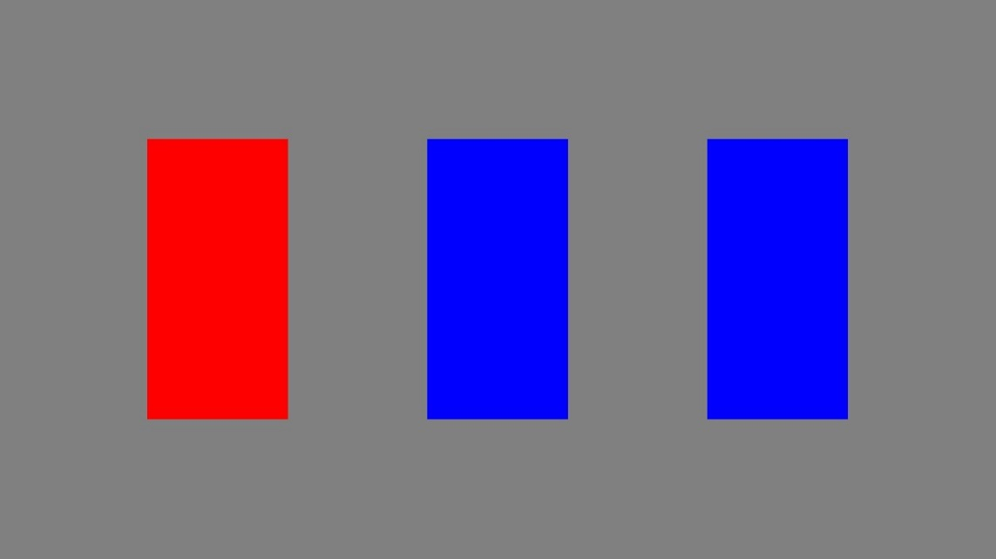This dual N-back procedure (Heathcote et al., 2015) tests a participant’s working memory by requiring the participant to remember two pieces of information about a series of stimuli. In this experiment, participants will be presented with both an auditory and visual cue. For the auditory cue, the participant will hear the letter “P,” Y,” or “O.” For the visual cue, three blue doors will be presented, with one of these doors turning red for each trial. An example trial is pictured below.

Speaker: “Y”

The participants are instructed to remember the series of both stimuli and make a go/stop decision if either the letter or door was used two trials before the current presentation. Participants are taught this task in sections, providing multiple blocks of practice for each stimuli type. The practice begins with a visual-only practice block of 12 trials with on-screen feedback given after each trial. This is followed by a non-feedback visual-only block, containing 27 trials. After the visual-only trials have been completed, the practice process is repeated with audio-only trials.

Once the practice blocks for single stimuli trials are completed, the participants practice dual n-back trials. The participants will complete two practice blocks of 27 trials, first with feedback and then without. At the conclusion of this final practice, participants will begin 16 blocks of 27 trials (with no-feedback provided). The block type will be randomized, with eight dual trial blocks, four visual-only trial blocks, and four audio-only trial blocks. Participants are required to take at least a 30 second break between each round. For all trials, the response times and accuracies are recorded.

The creators of this task performed split-half reliability analyses for varying numbers of trials for this assessment, and recommended between 200 and 400 trials to insure strong reliability (> 0.90). As the current version of the dual N-back procedure utilizes 400 experimental trials (not including the two trials discarded from the beginning of every block), this assessment is also expected to have high reliability.

Note: Some components of this assessment have been updated for ease of use and visibility since the version created by Heathcote et al. (2015), but the experimental design remains the same.

Heathcote, A., Coleman, J. R., Eidels, A., Watson, J. M., Houpt, J., & Strayer, D. L. (2015). Working memory’s workload capacity. *Memory & Cognition*, *43*, 973-989. https://doi.org/  
10.3758/s13421-015-0526-2